HN Math III Notes Name ______________________

Unit 2 Day 7: Graphing Exponential and Logarithmic Functions

**MCj04382150000[1]**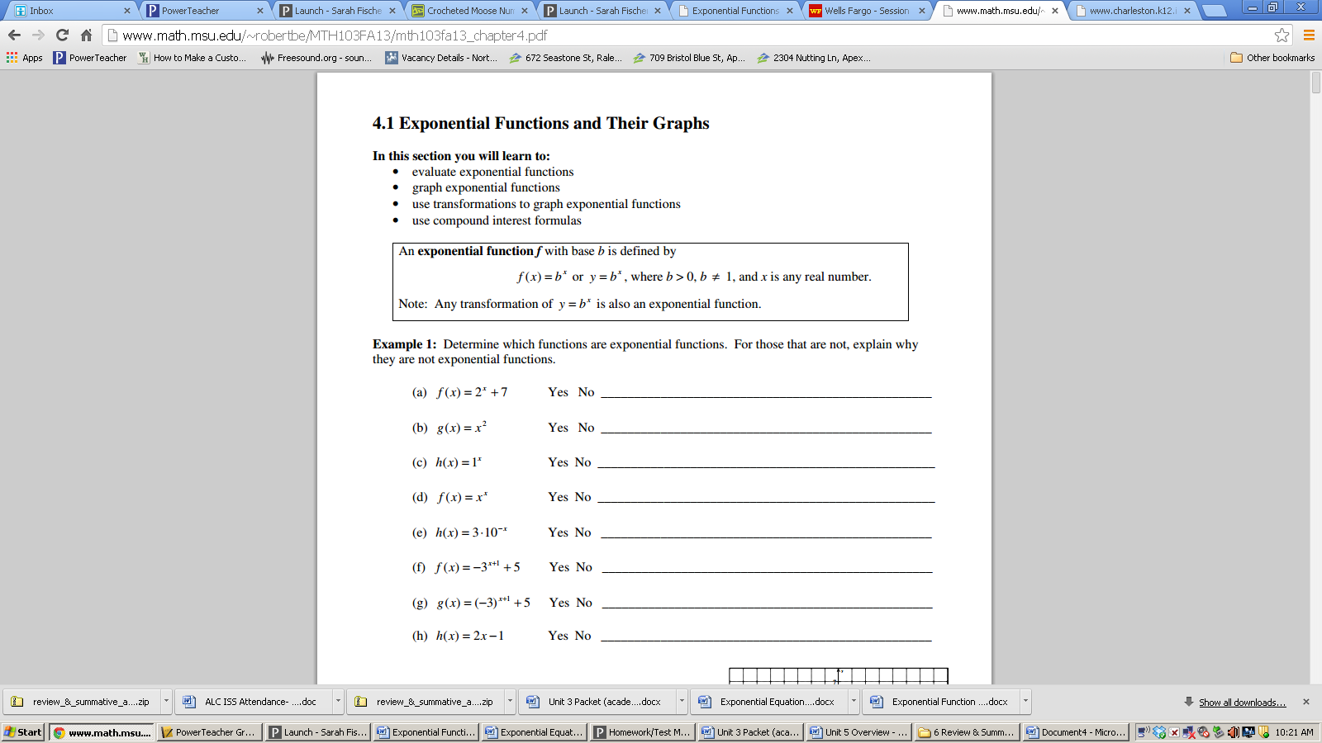

**Part I:**

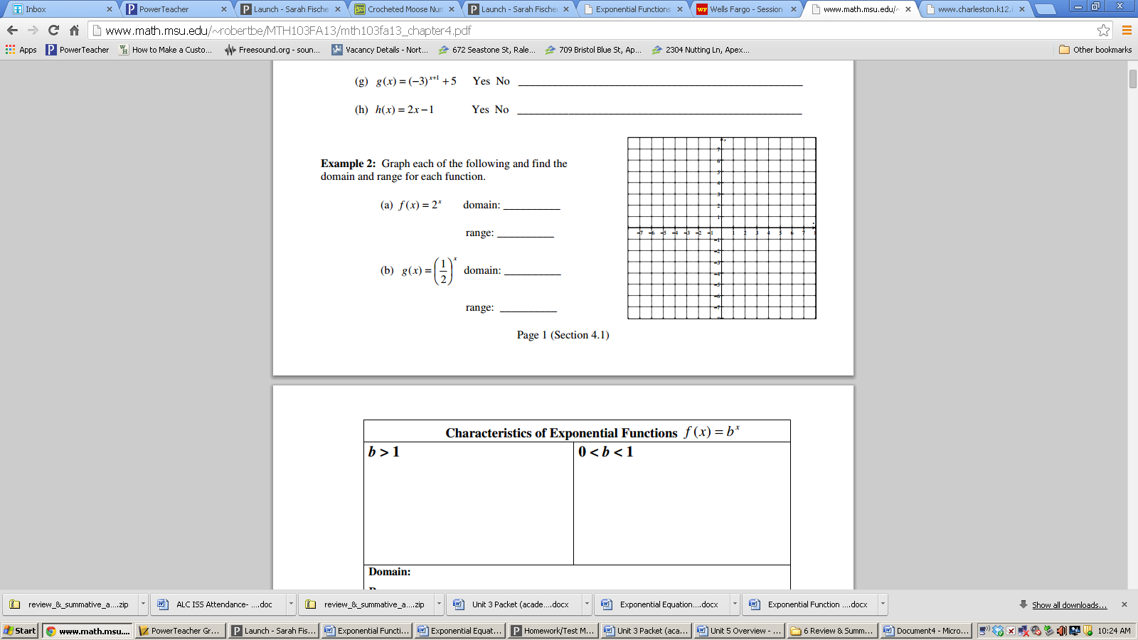

**Part 2:**

**Horizontal Asymptote:** an “invisible” line that the graph of a function approaches.

Identify the horizontal asymptote of (a): Identify the horizontal asymptote of (b):

Identify the y-intercept of (a): Identify the y-intercept of (b):

End behavior: End Behavior:

**Transforming Exponential Functions**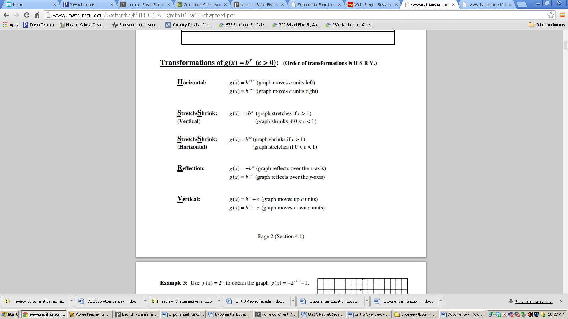

**Translate left or right:**

**Vertical stretch or compression:**

**Horizontal stretch or compression:**

**Reflections:**

**Translate up or down:**

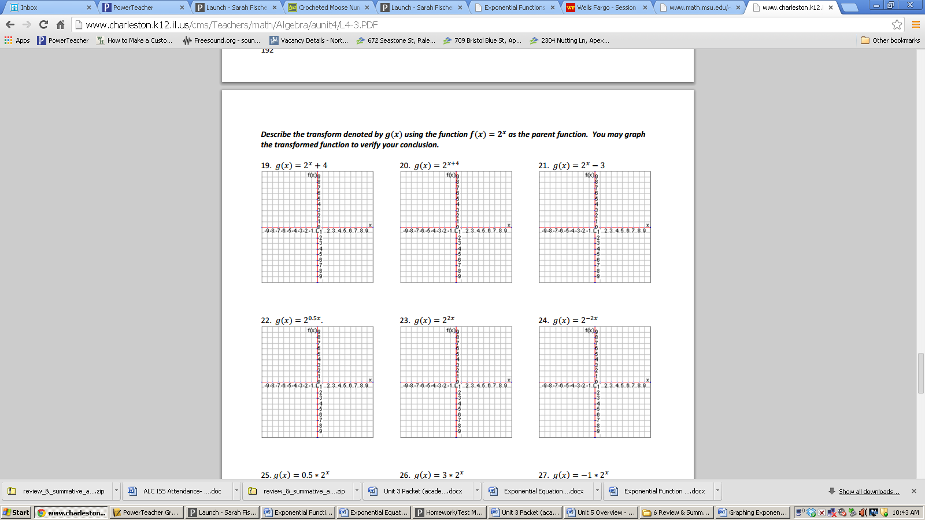**Part 3: Describe the transformation using the function f(x) = 2x as the parent function. Then graph the function. For each, identify the domain, range, y-intercept, the asymptote, and the end behavior as x🡪 and - $∞$ and the horizontal asymptote.**

3.

2.

1.

**Domain: __________ Domain: ___________ Domain: ___________**

**Range: ___________ Range: ____________ Range: ____________**

**Y-Intercept: ________ Y-Intercept: _________ Y-Intercept: _________**

**Asymptote: _________ Asymptote: __________ Asymptote: __________**

**End Behavior: _______ End Behavior: _________ End Behavior: ________**

**_______ __________ _________**

**Part 4: Graphing and Transforming Logarithmic Functions**

The _______________________________ function is the _____________________ of the exponential function.

**Now let’s use $f(x)=2^{x}$ to explore its inverse, $f^{-1}\left(x\right)=\log_{2}{x}$**

1. Complete the table to get the characteristic points of $f(x)=2^{x}$ and then sketch the graph.

|  |  |
| --- | --- |
| $x$ | $$f\left(x\right)=2^{x}$$ |
| –1 |  |
| 0 |  |
| 1 |  |
| 2 |  |

Asymptote: ________________

Domain: ___________________

Range: ____________________

1. Graph 

1. Complete the table to get the characteristic points of $f^{-1}\left(x\right)=\log_{2}{x}$ and then sketch the graph.

|  |  |
| --- | --- |
| $$x$$ | $$f^{-1}\left(x\right)=\log_{2}{x}$$ |
|  | –1 |
|  | 0 |
|  | 1 |
|  | 2 |

Asymptote: ________________

Domain: ___________________

Range: ____________________

Domain: __________________

Range: __________________

Asymptote: _________________

4. Graph  5. Graph 

Domain: __________________ Domain: __________________

Range: __________________ Range: __________________

Asymptote: _________________ Asymptote: ______________

**Part 5: Solve Graphically (Show a sketch as your work)**

1. Solve: $\log_{3}\left(x-4\right)=-\log_{5}x$ 2. Solve: $\log_{2}\left(3x+5\right)=4^{x}$