1. {(2,4), (7,6), (1,3), (3,2)}

Domain: ______________ Range: _______________ Function? _____________

**Function Notation**:

Use the graph below to find the values.

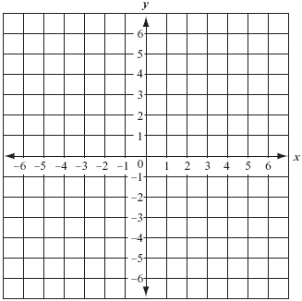2)  g(x) = x2 – 2 3) What is f(1), f(5), f(6)?

1. 
2. 
3. 

**Graphing:**

Put into slope-intercept form and then graph the lines. Find the following information:

4) 3x + y = 4 5) 4 + 2y = 10x 6) 

Slope: _____________ Slope: _______________ Slope _______________

y-int: _____________ y-int: _______________ y-int: _______________

Domain: ____________ Domain: _____________ Domain: _____________

Range: _____________ Range: ______________ Range: ______________

Function? ______ Function? ______ Function? ______



7)Determine the x- and y-intercepts for each equation, then graph using the intercepts.

a)  b) 

x-intercept __________ x-intercept __________

 y-intercept __________ y-intercept __________