HN Math III Notes Name ___________________________
Unit 4, Day 2: Cross Sections and Rotations Date _________________ Period _____

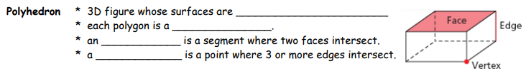
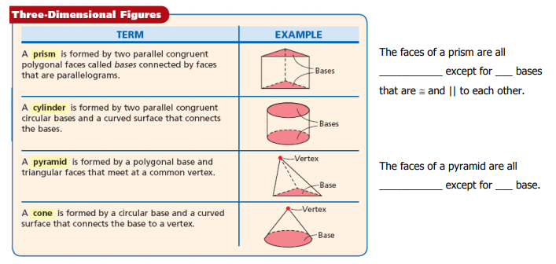

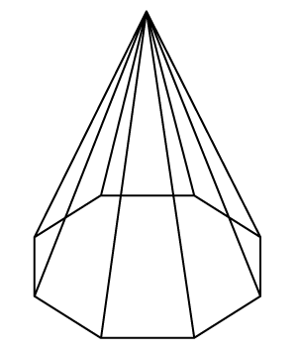
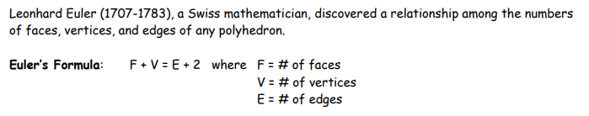
Ex: Use Euler’s Formula to determine how many edges:

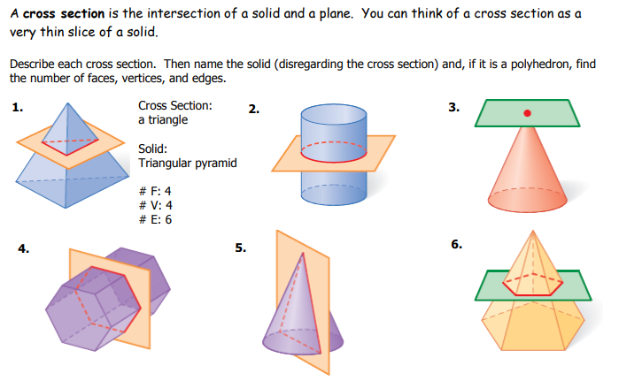

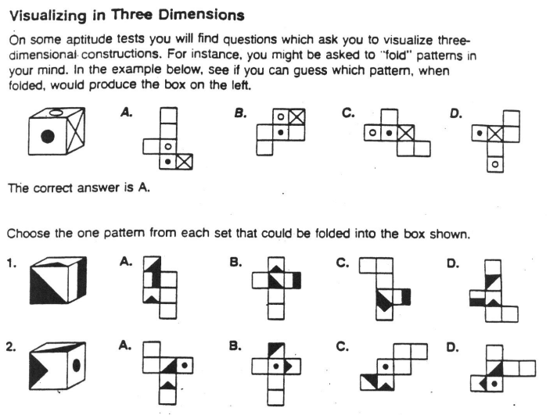
HN Math III Warm Up Name ________________________
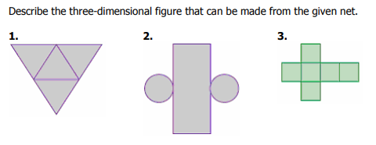
Match each solid to it’s net:
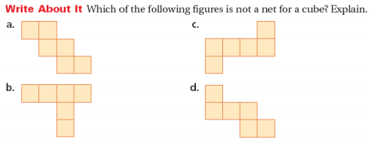
8.

HN Math III Warm Up Name ________________________
Match each solid to it’s net:
8.

