**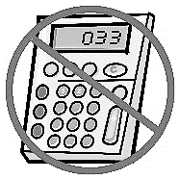PRODUCTS AND ZEROS OF POLYNOMIALS**

**Warm Up:** For the following functions, find the (i) zeros, and (ii) y-intercept.

$h\left(x\right)=x^{2}+4x$

$j\left(n\right)=-n^{2}+n+6$

$k\left(x\right)=(2x-1)(x+5)$



**ZEROS OF POLYNOMIALS**

1. Consider the function in factored form: $q\left(x\right)=x\left(x-3\right)\left(x+5\right).$
   1. What are the zeros of $q\left(x\right)?$ How do you know?
   2. Find the equation for $q\left(x\right)$ in standard polynomial form. Show your work.
   3. Identify the degree of $q(x)$. How could you have predicted the degree based on the original factored form?
   4. **Sketch $q\left(x\right)$** below, labeling the x-intercepts, y-intercept, and local maximum and minimum points.

****Macintosh HD:Users:cameronburns:Desktop:new doc 2017-01-18 20.30.38_20170118203041.pdf

1. The graph below is a cubic polynomial $c\left(x\right).$
   1. **Without a calculator**, use the graph to write a possible equation in *factored* form for $c\left(x\right).$
   2. Express the equation you created in *standard* polynomial form.



* 1. Compare the overall shape of the graph, the local max/min points, and intercepts of the graph produced by your equation to the graph. Adjust your equation if needed to give it a better fit.

1. Look back on your work from problems 1 and 2 to develop ideas and conjectures about the following questions.
   1. How can you tell the **zeros** of a polynomial function when its rule is written in factored form?
   2. How can you tell the **degree** of a polynomial function when its rule is written in factored form?
   3. Which properties of a polynomial and its graph are shown best when written in factored form? Which properties of a polynomial and its graph are shown best when written in standard form?

**“ADVANCED” MULTIPLICATION**

Recall the distributive property you learned early in your experience with variables:

$$3\left(x+4\right)$$

$$3x+12$$

More recently, you have used the distributive property to expand products of binomials like:



$$(2x+4)(x-3)$$

$$2x^{2}+4x-6x-12$$

$${2x}^{2}-2x-12$$

1. Suppose you were asked to expand the product $(2x+1)({3x}^{2}+2x+4)$.
   1. How could you use the *distributive* property to expand this polynomial? Write it in standard polynomial form.
   2. Use a calculator to find and compare the zeros of $p\left(x\right)=2x+1$ and $q\left(x\right)=3x^{2}+2x+4$ (separately) with the zeros from its product, $p\left(x\right)q(x)$, that you found in part a.

**REPEATED ZEROS**



1. Consider the functions $r\left(x\right)={(x-3)}^{2}$ and $s\left(x\right)={(x+3)}^{3}$.
   1. Expand both expressions. Identify the degree of each polynomial.
 $$r\left(x\right)={(x-3)}^{2}$$

 $$s\left(x\right)={(x+3)}^{3}$$

 2. How many zeros do $r\left(x\right)$ and $s\left(x\right)$ each have?
   3. What degree is the product $r\left(x\right)s\left(x\right)$? How many zeros does it have?
   4. Sketch $r\left(x\right)$, $s\left(x\right),$ and $r\left(x\right)s\left(x\right)$.
2. ****Consider the function $t\left(x\right)=(x-3){(x+4)}^{2}$.
   1. Expand the expression. Identify the degree of the result.
   2. What are the zeros of $t\left(x\right)$?
   3. Sketch the graph of $t\left(x\right)$ to show that the number of zeros and the degree of the polynomial are not the same. Explain why that happens.

**NOTES AND RECAP:**

**Sketching Polynomials: Practice**

Use the following functions to answer the questions below. Then, sketch a graph of the polynomial.



$f\left(x\right)=x(x-6)(x-5)$

What is the leading coefficient of the function?

What is the degree of the function?

Is the function ODD or EVEN?

What are the zeros of the function?

Multiplicity?

What is the y-intercept of the function?

What will the end behavior of the function be?

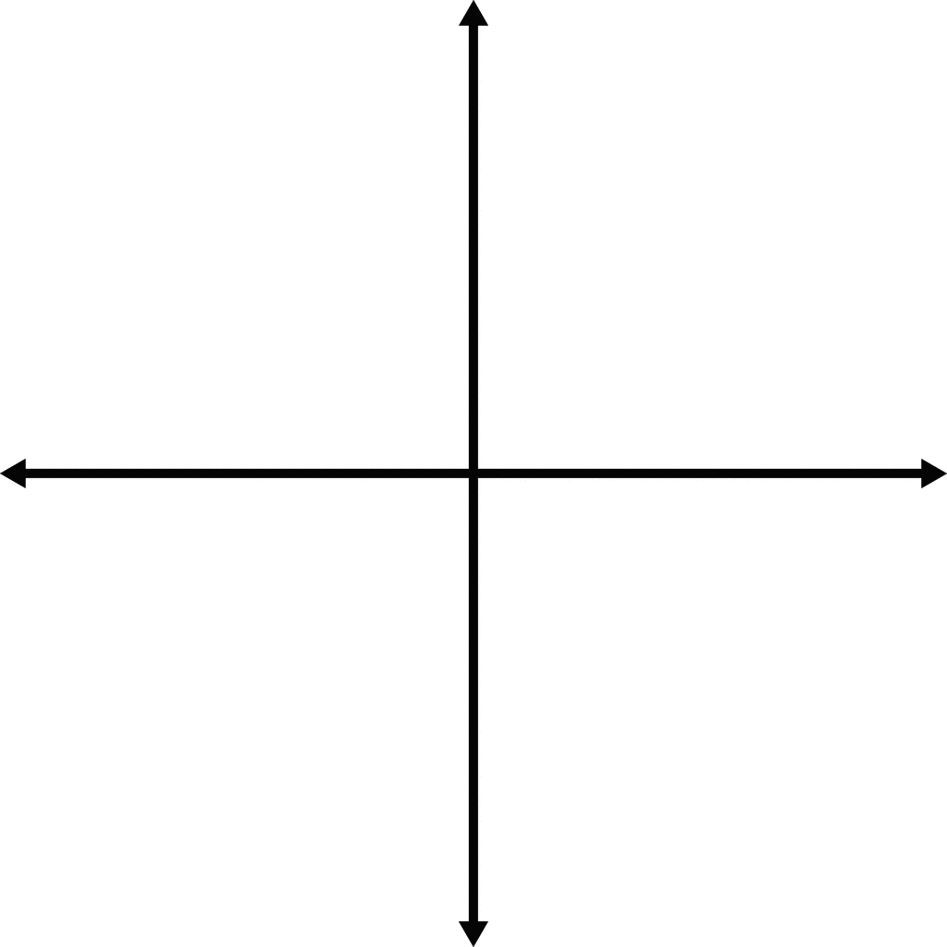



$f\left(x\right)=-{(x-2)}^{2}{(x+1)}^{3}$

What is the leading coefficient of the function?

What is the degree of the function?

Is the function ODD or EVEN?

What are the zeros of the function?

Multiplicity?

What is the y-intercept of the function?

What will the end behavior of the function be?





$h\left(x\right)=(6+x)(x-2){(3-x)}^{2}$

Leading term:

Degree:

Zeros & Multiplicity:

y-intercept:

End behavior:



$j\left(x\right)=-x^{3}{(x-2)}^{2}{(2x-10)}^{2}$

Leading term:

Degree:

Zeros & Multiplicity:

y-intercept:

End behavior:

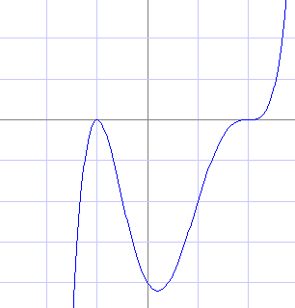Write a possible function in factored form for the following graphs.

1. 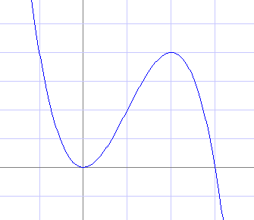

Equation: \_\_\_\_\_\_\_\_\_\_\_\_\_\_\_\_\_\_\_\_\_\_\_\_\_\_\_\_\_\_\_\_ Equation: \_\_\_\_\_\_\_\_\_\_\_\_\_\_\_\_\_\_\_\_\_\_\_\_\_\_\_\_\_\_\_\_