Homework Day 3: Inscribed Angles Name: __________________________

HN Math 3 Unit 6 Part II

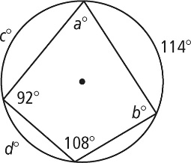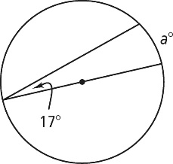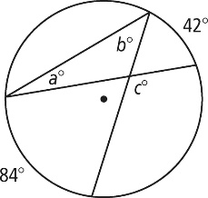**Directions:**  Find the value of each variable. For each circle, the dot represents the center.



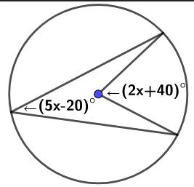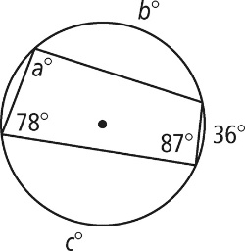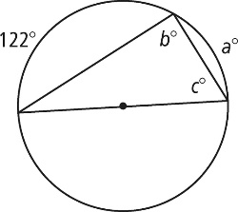



**Directions:** Find the value of each variable. Lines that appear to be tangent are tangent. For each circle, the dot represents the center.

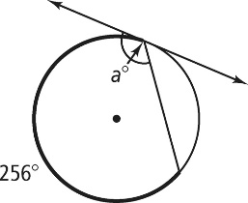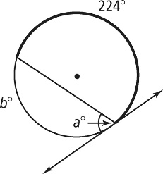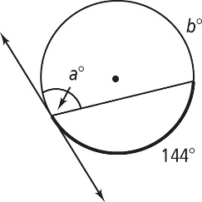



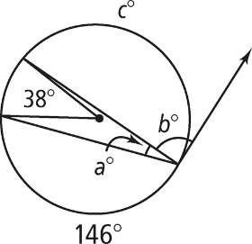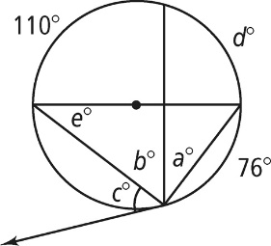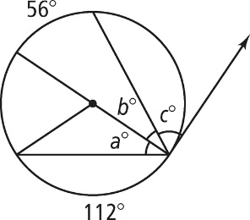

4. 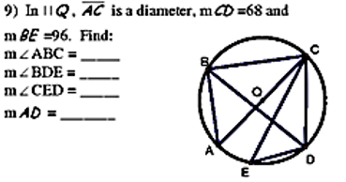In ʘO, $\overline{AC}$ is a diameter and m $\hat{CD}$ = 68 and m $\hat{BE}=96.$ Find:

m∠ABC = _____

m∠BDE = _____

m∠CED = _____

m $\hat{AD}$ = _____