HN Math 3 Unit 6, Day 4 Quadrilaterals Name _______________________
SWBAT use the properties of quadrilaterals to solve for unknowns and complete proofs.

Rectangle | Rhombus | Square
Def: A rectangle is a parallelogram with four right angles. | Def: A rhombus is a parallelogram with four congruent sides. | Def: A square is a parallelogram with 4 congruent sides and 4 right angles.
A rectangle has all the properties of a parallelogram PLUS:  - 4 right angles  - Diagonals are congruent  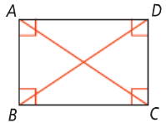 | A rhombus has all the properties of a parallelogram PLUS:  - 4 congruent sides  - Diagonals bisect angles  - Diagonals are perpendicular  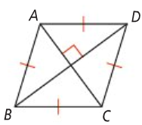 | A square has all the properties of a parallelogram PLUS:  - All the properties of a rectangle  - All the properties of a rhombus  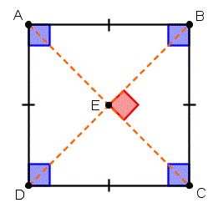

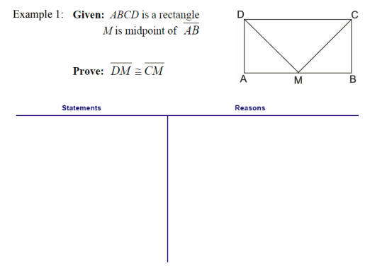
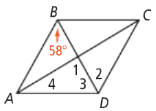
Example 2: Using the diagram to the right to answer the following if ▭ABCD is a rhombus.
- Find the m∠1.
- Find the m∠2.

- Find the m∠3.
- Find the m∠4.

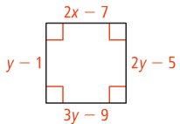
Example 3: Solve for each variable if the following are rhombi.

Trapezoid | Def: A trapezoid is a quadrilateral with exactly one pair of parallel sides, called bases, and two nonparallel sides, called legs. | Isosceles Trapezoids | Trapezoid Midsegment
 |  | Def: An isosceles trapezoid is a trapezoid with congruent legs. | Def: The median (also called the midsegment) of a trapezoid is a segment that connects the midpoints of the two legs.
 |  | A trapezoid is isosceles if there is only:  - One set of parallel sides  - Base angles are congruent  - Legs are congruent  - Diagonals are congruent  - Opposite angles are supplementary | Theorem: If a quadrilateral is a trapezoid, then  a) the midsegment is parallel to the bases and  b) the length of the midsegment is half the sum of of the bases
 |  | 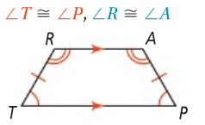 | 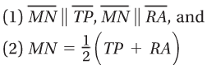  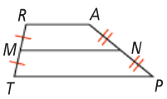
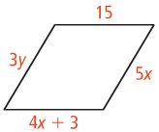
- b)

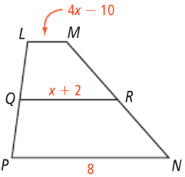
Example 4: What are the values of x and y in the Example 5: $\overline{QR}$ is the midsegment of isosceles triangle below if $\overline{DE}$ || $\overline{DC}$? trapezoid LMNP. What is x and LM?

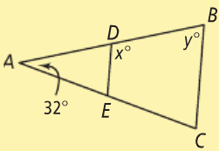

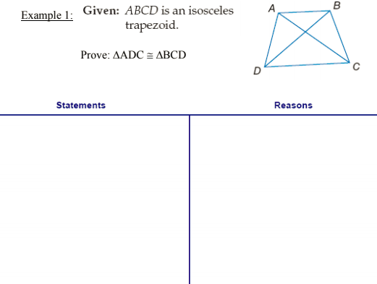

Kite | Def: A kite is a quadrilateral with two pairs of adjacent, congruent sides. | If a quadrilateral is a kite, then:
 |  | Its diagonals are perpendicular. | Its diagonals bisect the opposite angles. | One pair of opposite angles are congruent. | One diagonal bisects the other.
 |  | 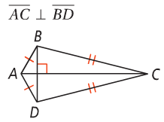 | 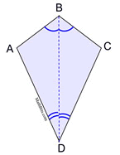 | 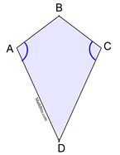 | 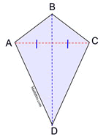

Example 6: Quadrilateral DEFG is a kite. What are m∠1, m∠2, and m∠3?
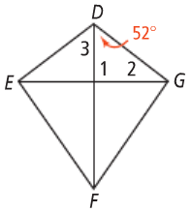
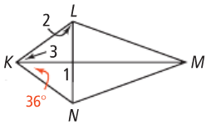
Example 7: Quadrilateral KLMN is a kite. What are m∠1, m∠2, and m∠3?

