Unit 6, Day 9 Homework: Angles and Segments Name: __________________________
Math 3

Directions: Solve for x.
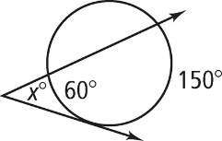
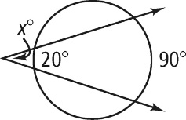
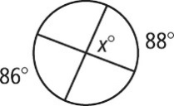

Directions: Solve for each variable listed.
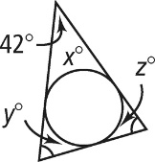
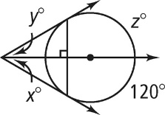
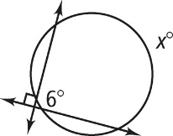

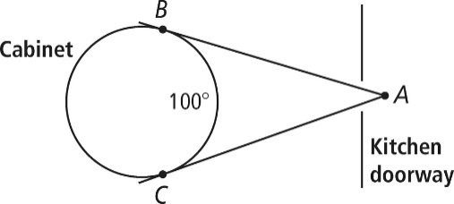
- There is a circular cabinet in the dining room. Looking in from another room at point A, you estimate that you can see an arc of the cabinet of about 100°. What is the measure of ∠A formed by the tangents to the cabinet?

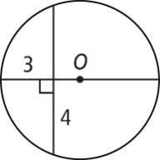
Directions: Find the diameter of O. A line that appears to be tangent is tangent. If your answer is not a whole number, round to the nearest tenth.
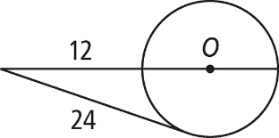
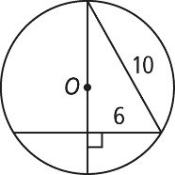

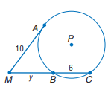
Directions: Solve for x.
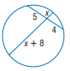
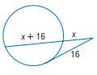
- 12. 13.

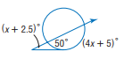
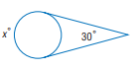
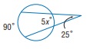
14. 15. 16.

