Day 5 Homework: Equations of Circles Name: __________________________
Unit 6 part II - Math 3

Note: If r² is not a perfect square then leave r in simplified radical form but use the decimal equivalent for graphing. Example:

- Graph the following circle:

- (x - 3)² + (y + 1)² = 4
- (x – 2)² + (y – 5)² = 9
- (y + 4)² + (x + 2)² = 16

- For each circle, identify its center and radius.

- (x + 3)² + (y – 1)² = 4
- b. x² + (y – 3)² = 18
- (y + 8)² + (x + 2)² = 72

Center:_____________

Radius:_____________

Center:___________

Radius:____________

Center:_____________

Radius:_____________

- Write the equation of the following circles:

- Give the equation of the circle that is tangent to the y-axis and center is (-3, 2).

- Compare and contrast the following pairs of circles

a. Circle #1: (x - 3)²+ (y +1)² = 25
Circle #2: (x + 1)² + (y - 2)² = 25

b. Circle #1: (y + 4)²+ (x + 7)² = 6
Circle #2: (x + 7)² + (y + 4)² = 36

- Find the standard form, center, and radius of the following circles:

- x² + y² – 4x + 8y – 5 = 0
- 4x² + 4y² + 36y + 5 = 0

Center:________ Radius:_________ Center:________ Radius:_________
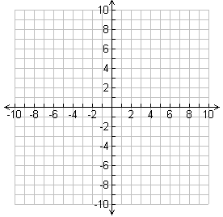
- Graph the following circles.

- x² – 2x + y² + 8y – 8 = 0
- x² + y² – 6x + 4y – 3 = 0

- Give the equation of the circle whose center is
(5,-3) and goes through (2,5)
- Give the equation whose endpoints of a diameter at (-4,1) and (4, -5)

- Give the equation of the circle whose center is
(4,-3) and goes through (1,5)
- Give the equation whose endpoints of a diameter at (-3,2) and (1, -5)

