HN Math 3 Notes Inscribed Angles Name _______________________
Unit 6 Part II, Day 3 Apply the rules and theorems of inscribed angles to solve for unknowns.

- Basic Information/Central Angles
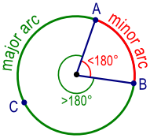
Major Arc: | Minor Arc: | Semicircle:
An arc of a circle measuring more than or equal to 180˚ | An arc of a circle measuring less than 180˚ | An arc of a circle measuring 180 ˚

Central Angle: | A central angle is an angle formed by two intersecting radii such that its vertex is at the center of the circle. | 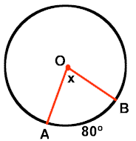
Central Angle Theorem: | In a circle, or congruent circles, congruent central angles have congruent arcs.

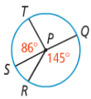
Example 1: Identify the following in ☉P at the right. For parts d-f, find the measure of each arc in ☉P.

- A semicircle
- A minor arc
- A major arc

- $\hat{ST}$
- $\hat{STQ}$
- $\hat{RT}$

Example 2: Find the length of $\overline{AB}$
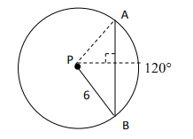

Example 3:
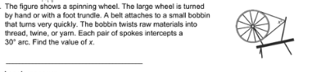

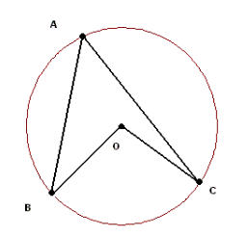
- Inscribed Angles
1
2

- Looking at ∠1 and ∠2, what conjecture would you
make about the size of the angles with respect to
each other? (Circle one)

m∠1 > m∠2 m∠1 < m∠2 m∠1 = m∠2

- Use patty paper to trace ∠1 OR ∠2. Investigate to
determine if your conjecture was correct.

- After tracing and investigating, can you make a more
specific conjecture about the relationship between
m∠1 and m∠2?

- If m$\hat{BC}$ = 70, find m∠1 and m∠2.

Inscribed Angle: | An inscribed angle is an angle with its vertex "on" the circle, formed by two intersecting chords. | 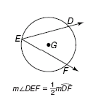
Inscribed Angle Theorem: | The measure of an inscribed angle is half the measure of its intercepted arc.

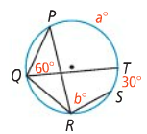
Example 1: What are the values of a and b? You Try! What are the m$∠A$, m$∠B$, m$∠C$, and m$∠D$?
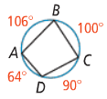

Corollary 1: | Corollary 2: | Corollary 3:
Two inscribed angles that intercept the same arc are congruent. 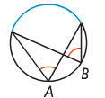 | An angle inscribed in a semicircle is a right angle.  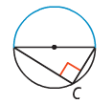 | The opposite angles of a quadrilateral inscribed in a circle are supplementary.  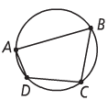

Example 2: What is the measure of each numbered angle?

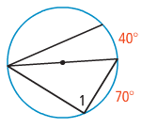
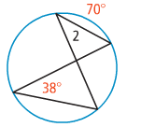

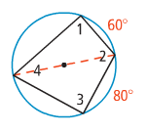
Example 3: Find the measure of each numbered angle in the diagram to the right.

- $m∡1=$
- $m∡2=$

- $m∡3=$
- $m∡4=$

Tangent Chord Angle: | An angle formed by an intersecting tangent and chord has its vertex "on" the circle. | 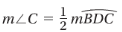  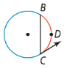
Tangent Chord Angle Theorem: | The tangent chord angle is half the measure of the intercepted arc.  Tangent Chord Angle = ½ (Intercepted Arc)

Example 4: In the diagram, $\overset{⃡}{SR}$ is tangent to the circle at Q. If $m\hat{PMQ}=212$, what is the $m∠PQR$?
Example 5: In the diagram, $\overset{⃡}{KJ}$ is tangent to$⊙O.$ What are the values of x and y?

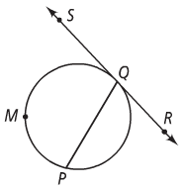
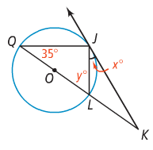

Find the value of each variable. For each circle, the dot represents the center.

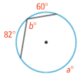
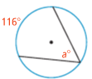
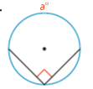

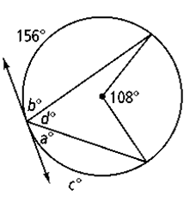
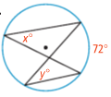
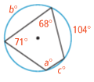

- Use the diagram at the right to complete the following:
- Name an inscribed angle.

- Name an arc intercepted by ∠BAC.

- If m∠BPC = 42, find m∠BAC.

c.

- $\overline{RS}$ and $\overline{TU}$ are diameters of ʘA. Find m∠BRT and m∠TRS.

RULE: Two chords are parallel if and only if the intercepted arcs are congruent.

10. In ʘZ, $\overline{AB}$ $∥$ $\overline{DC}$, m$\hat{BC}$ = 94, m∠AZB = 104. Find: 11. In ʘA, $\hat{PQ}$ ≅ $\hat{RS}$ and m∠1 = 38 and m$\hat{QR}$ = 28. Find:

m$\hat{AB}$ = ______
m∠BAC = ______ m∠T = _____
m∠ADB = ______ m∠2 = _____
m$\hat{AD}$ = ______ m∠3 = _____
m$\hat{CD}$ = ______ m∠4 = _____
m∠DAC = ______ m$\hat{PT}$ = _____
m∠AEB = ______

