1. **Recall:** General Area Formulas From Previous Math Courses (You need to know these)

Area of Rectangle = bh

Area of Triangle = ½bh

Area of Trapezoid = ½ (b1 + b2)h

Area of Circle = πr2

**Optional but helpful:**

Area of an equilateral Triangle = $\frac{\sqrt{3}}{4}s^{2}$

Area of a polygon = ½ Pa where P is the perimeter of the polygon and a is the length from the “center” of the

polygon to the midpoint of the side of the polygon.

1. **SURFACE AREA OF PRISMS AND PYRAMIDS**

To find the surface area of PRISMS and PYRAMIDS, you need to:

1. Imagine or draw the net that forms the 3D shape.
2. Find the AREA of each section of the net.
3. Add the areas together.

**EX 1:** A rectangular prism measures 7 inches by 5 inches by 10 inches. Find the surface area of the prism.

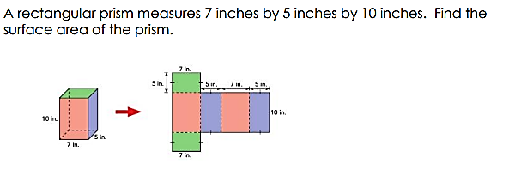

**EX 2:** Alicia makes a pyramid that has an equilateral triangle as its base. The other three faces are congruent isosceles triangles. She measures the lengths as shown below. Find the surface area.

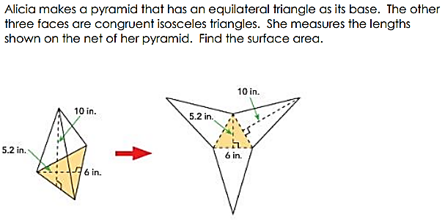

**EX 3:** Find the surface area of the hexagonal prism.

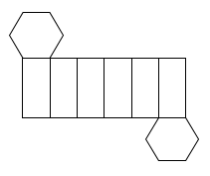

12 cm

6 cm

8 cm

1. **SURFACE AREA OF CONES AND CYLINDERS**

These problems will generally be done in the same way, however, you need to consider how the net is formed and how it relates to the given 3D shape.

**CYLINDER: CONE:**

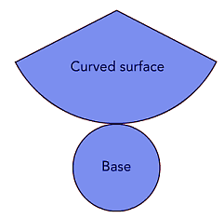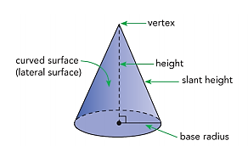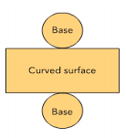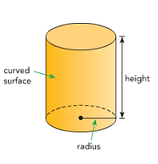

Consider the cylinder above when you make the net:

* How is the length of the rectangle determined?
* How is the width of the rectangle determined?
* How do you find the area of the base?

**SURFACE AREA OF CYLINDER:**

A = area of 2 bases + area of curved surface

$$A=2πr^{2}+2πrh$$

Consider the cone. The curved surface is not a shape known from a previous math course.

**SURFACE AREA OF CONE:**

A = area of the base + area of curved surface

$$A=πr^{2}+πrl$$

**EX 4:** Find the surface area of the cones.



a. b.

1. 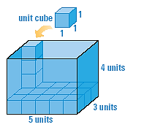**VOLUME OF PRISMS AND CYLINDERS**

The general idea behind volume: determine how much space is inside the shape.

V= Area of the Base x height

$$V=Bh$$

**EX 5:** Find the volume of the right prism and right cylinder.

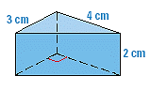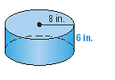

a. b.

1. **VOLUME OF PYRAMIDS AND CONES**

Same basic idea here, however, there isn’t nearly as much space inside a pyramid or cone as there is a prism or cylinder, so the formula changes for these.

Volume = $\frac{1}{3}$ Area of the Base x height

$$V=\frac{1}{3}Bh$$

**EX 6:** Find the volume of the pyramid and the cone.

1.  b.

**EX 7:** Find the unknown length if the volume of the cone is 170 cm3



1. **COMPOSITE FIGURES**

Use knowledge of finding the surface area and volume of basic figures to find more complex areas and volumes.

**EX 8:** The walls and roof of the greenhouse shown below is going to be resurfaced with a new material. How many square feet of material will be needed?

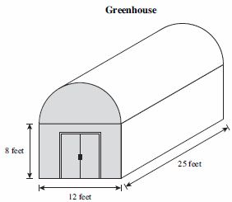

Given that the new material costs $12.50 per square foot, how much will it cost to replace the siding and roof?

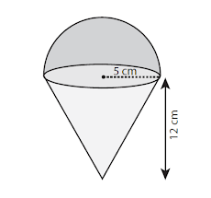**EX 9:** A sno-cone from the state fair is shown at the right. Assuming that your cone is completely filled, what is the volume of your frozen treat? (volume of a sphere is $V=\frac{4}{3}πr^{3}$)

Given that there are roughly 29.6 cm3 in 1 ounce, about how much frozen treat will you have consumed if you ate the whole sno-cone?

**HN Math III** Day 3 Homework Name ____________________________

1. Find the surface area of a right rectangular prism with a height of 2 feet, a length of 5 feet and a width of 4 feet.
2. Find the surface area and volume:
3. 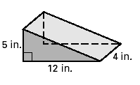 b. base:

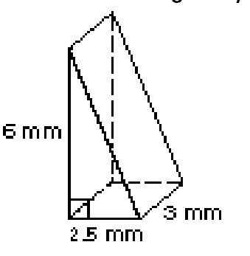

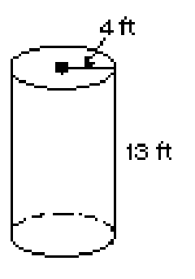

c. d.

1. Find the surface area of a cone that has a diameter of 11 ft. and a slant height of 7.2 ft.
2. Use the given measurements to solve for x.

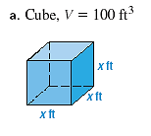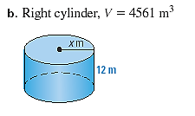

1. What is the surface area of the solid shown below?

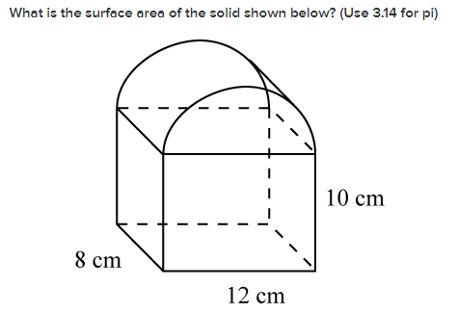

1. This figure shows a can of three tennis balls. The can is just large enough so that the tennis balls will fit inside with the lid on. The diameter of each tennis ball is 2.5in. **Find the percent of the can occupied by the tennis balls**.

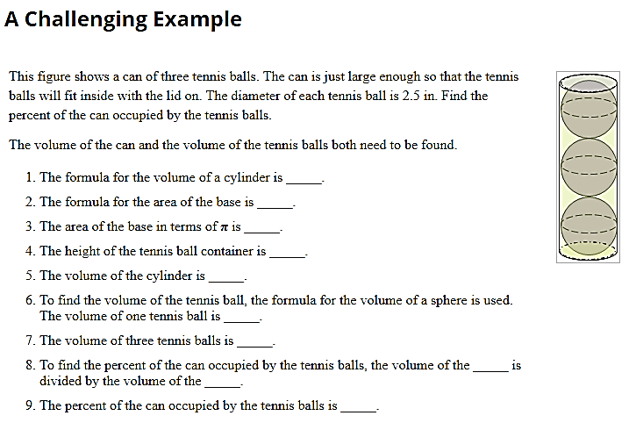**Volume of can:**

**Volume of tennis balls (three):**

**Percent of can occupied by tennis balls:**