HN Math 3 Unit 6, Day 7 **Chords & Arcs of Circles** Name ____________________

*Solve for unknown variables using theorems about chords and arcs of circles.*

The given point is called the _____________.

This point names the circle.

Any segment with _________________ that are the center and a point on the circle is a _______________.

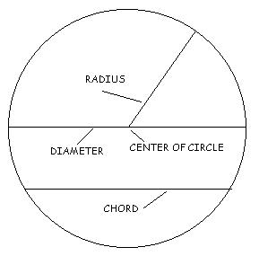

Any segment with ____________________ that are on a circle is called a _______________.

A _____________ that passes through the center is a **______________** of a circle.

**Example 1:** Name the circle, a radius, a chord, and a diameter of the circle.

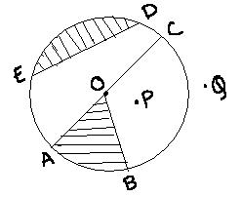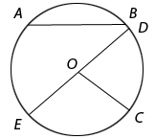

Circle: ___________ Circle: ___________

Radius: ___________ Radius: ___________

Chord: ____________ Chord: ____________

Diameter: __________ Diameter: __________

Since a _________________ is composed of two radii, then **d = 2r** and **r = d/2**

-----------------------------------------------------------------------------------------------------------------------------------------------------------

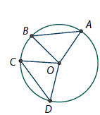By definition, two arcs have the same measure if and only if their central angles are congruent. But what about the corresponding chords? Consider the chords $\overline{AB}$ and $\overline{CD}$ and their central angles pictured at the right.

* 1. Suppose $AB=CD$. Using triangle congruence, prove that $m∠AOB=m∠COD$ and $m\overset{⏜}{AB}=m\overset{⏜}{CD}$.
  2. Suppose $m\overset{⏜}{AB}=m\overset{⏜}{CD}$. Using triangle congruence, prove that $AB=CD$.

These Rules follow:

|  |  |  |
| --- | --- | --- |
| **Theorem 1:** | **Converse Theorem 1:** |  |
| Within a circle or in congruent circles, congruent central angles have congruent arcs. | Within a circle or in congruent circles, congruent arcs have congruent central angles. |
| **Theorem 2:** | **Converse Theorem 2:** |  |
| Within a circle or in congruent circles, congruent central angles have congruent chords. | Within a circle or in congruent circles, congruent chords have congruent central angles. |
| **Theorem 3:** | **Converse Theorem 3:** |  |
| Within a circle or in congruent circles, congruent chords have congruent arcs. | Within a circle or in congruent circles, congruent arcs have congruent chords. |

**Use a piece of patty paper to trace the following diagram.**

1. 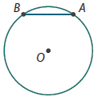Using the patty paper, how can you locate the midpoint of AB?
2. Find the midpoint of AB on the patty paper and label it M.
3. In your group, discuss any observations you can make about your diagram and note them here:
4. Label the diagram to the left with any conclusions made in class.

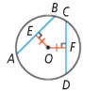Consider the following diagram:

1. Draw OB and OC.
2. What conclusions can be made? Note them here:
3. Based on part b, what conclusions can eventually be made about AB and CD?

These Rules follow:

|  |  |  |
| --- | --- | --- |
| **Theorem 4:** | **Converse Theorem 4:** |  |
| Within a circle or in congruent circles, chords equidistant from the center or centers are congruent. | Within a circle or in congruent circles, congruent chords are equidistant from the center (or centers). |
| **Theorem 5:** |  | |
| In a circle, if a diameter is perpendicular to a chord, then it bisects the chord and its arc. |
| **Theorem 6:** |  | |
| In a circle, if a diameter bisects a chord that is not a diameter, then it is perpendicular to the chord. |
| **Theorem 7:** |  | |
| In a circle, the perpendicular bisector of a chord contains the center of the circle. |

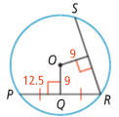**Example 1:** The following chords are equidistant from the center of the circle.

What is the length of RS?

**Example 2:** In $⊙$ O, $\overline{CD}⊥\overline{OE}, OD=15, and CD=24.$ Find x.

**Example 3:** Find the value of x to the nearest tenth.

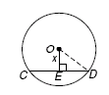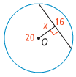

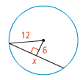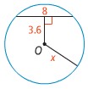**Example 4:** Find the value of x to the nearest tenth.



HN Math III: Chords & Arcs of Circles Name: __________________________

You try!

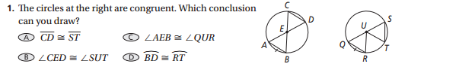

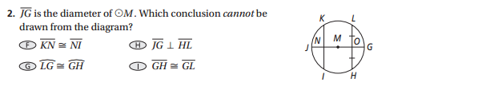

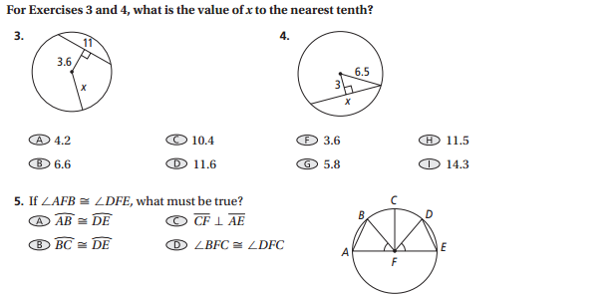



1. A student draws X with a diameter of 12 cm. Inside the circle she inscribes equilateral ∆ABC so that , , and  are all chords of the circle. The diameter of X bisects . The section of the diameter from the center of the circle to where it bisects  is 3 cm. To the nearest whole number, what is the perimeter of the equilateral triangle inscribed in X?
2. Solve for x.

