Parallelogram Proofs and Problems

Definition: A parallelogram is a quadrilateral with both pairs of opposite sides parallel.

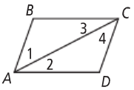
Example 1: Given: ▭ABCD is a parallelogram.
Prove: AB ≅ CD and BC ≅ DA.

Statement | Reason
- ABCD is a parallelogram | 1.
2. | 2. Definition of a parallelogram
- ∠1 ≅ ∠4, ∠3 ≅ ∠2 | 3.
4. | 4.
5. ∆ABC ≅ ∆CDA | 5.
6. | 6. CPCTC

Example 2: Given: ▭ABCD is a parallelogram.
Prove: ∠B ≅∠D

Statement | Reason
- ABCD is a parallelogram | 1.
2. | 2.
 | 3.
4. | 4.
5. | 5.
6. | 6.

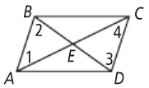
Example 3: Given: ▭ABCD is a parallelogram.
Prove: AC and BD bisect each other at E.

Statement | Reason
1. ABCD is a parallelogram | 1. Given
2. | 2.
3. | 3.
4. | 4.
5. | 5. ASA
6. | 6.
7. | 7. Definition of segment bisector

Properties of Parallelograms – use when GIVEN a pg.
Sides | Definition of Parallelogram: A parallelogram is a quadrilateral with both pairs of opposite sides parallel. | 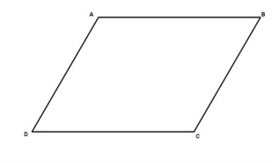
If a quadrilateral is a parallelogram,
the 2 pairs of opposite sides are congruent.
Angles | If a quadrilateral is a parallelogram,  the 2 pairs of opposite angles are congruent.
If a quadrilateral is a parallelogram,
the consecutive angles are supplementary.
Diagonals | If a quadrilateral is a parallelogram,  the diagonals bisect each other.

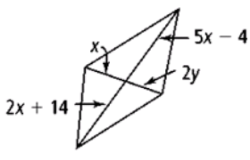
Example 4: For what values of x and y must each figure be a parallelogram?
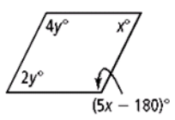

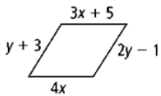
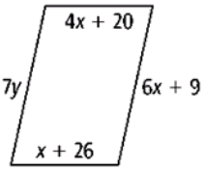

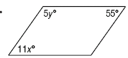
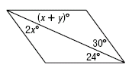

DAY 2: HOMEWORK

Use Parallelogram ABCD shown. Determine whether each of the statements is TRUE or FALSE. EXPLAIN your reasoning.
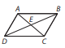

3.
4.

5.
6.

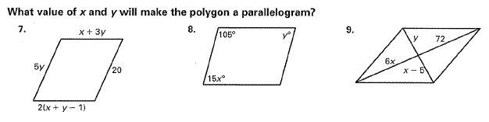

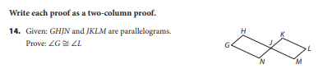
Statement | Reason
 | 1.
2. | 2.
 | 3.

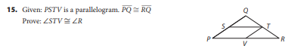
Statement | Reason
 | 1.
2. | 2.
 | 3.
4. | 4.

