HN Math III Name __________________________________
Unit 2, Day 3 Homework Date ______________________ period _____

Complete the following “Logical Arithmetic” problems based on your knowledge of exponent facts.

- Logical Arithmetic: If $5^{x}=125$, then x = ____.

- Logical Arithmetic: If ${10}^{x}=1$, then x = ____.

- Logical Arithmetic: If ${11}^{x}=121$, then x = ____.

Logical Arithmetic can be shortened into the word: LogArithm!
EXPLANATION:
LogArithm: base 2, (8)
IS ASKING … With base 2, what exponent gives you 8? So the answer to this question would be 3 (since 2³ = 8).

Use the above information to complete the following
- LogArithm: base 6, (1) = 5. LogArithm: base 2, (16) =

6. LogArithm: base 3, (81) = 7. LogArithm: base 5, $\frac{1}{25}=$

Complete the following:
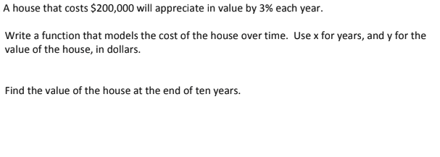

- The most recent virus that is making people ill is a fast moving one. Ten people are sick to begin, however, the virus is compounding continuously.

Write a function that models the virus’s growth over time.

If 30 people are sick on day 5, find the rate of growth.

