HN Math 3 Angle Measures & Segment Lengths Name ______________
Unit 6, Day 4 OBJ: Apply the rules and theorems of segments to solve for unknowns.

Theorem 1: | Theorem 2:
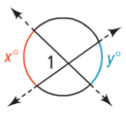  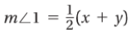 | 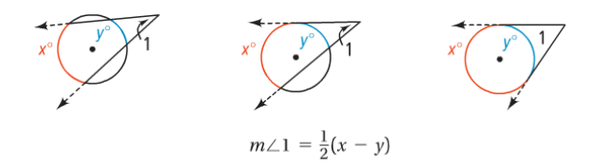

Theorem 3: | Theorem 4:
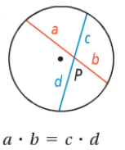 | 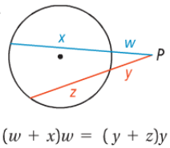 | 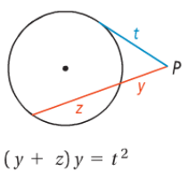

Example 1: Find each measure.
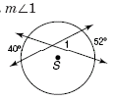

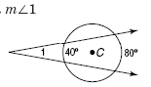
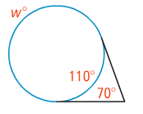

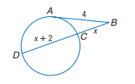
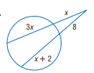
Example 2: Find the value of the variable.
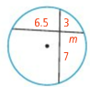
- b) c)

