Homework Unit 6, Day 4 Name: __________________________
HN Math 3

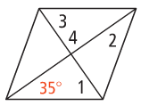
- Find the measure of each angle if the figure is a rhombus.

- Find the m∠1.
- Find the m∠2.

- Find the m∠3.
- Find the m∠4.

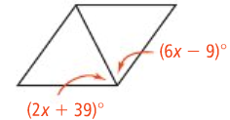
- Solve for x if the figure is a rhombus. 3. Solve for x if the figure is a rectangle.
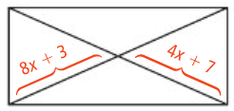

- Solve for the missing angle measures if the 5. What is the length of SW?
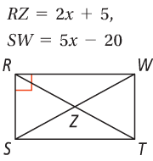
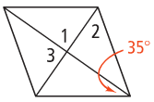
figure is a rhombus.

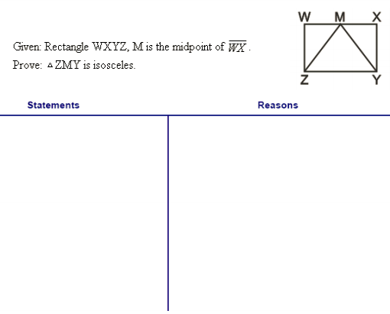

6.

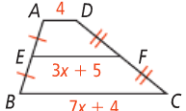
For questions #7-8, find x and the length of EF.

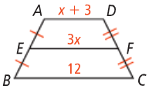

For questions #9-10, find the measures of the numbered angles in each kite.

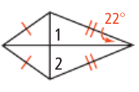
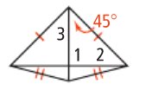

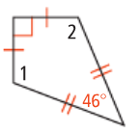
- Solve for the unknown angle measures in the kite shown.

