**PART I: Standard Form**

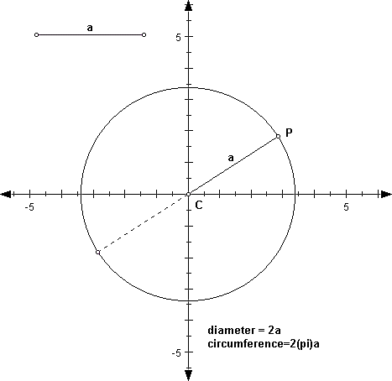

1

2

3

1

2

3

1. Consider the circle shown.
2. What are the coordinates of point P?
3. Draw a right triangle inside the circle using *a* as the hypotenuse.
4. What are the coordinates for the point where the legs meet?

Label this point Q.

1. What is the distance from the center to point Q?
2. What is the distance from point P to point Q?
3. What is the measure of *a*? How did you calculate it?

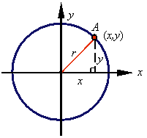

1. Now consider this circle where the coordinates of the point cannot be determined.
2. What are the coordinates for the point where the legs meet? Label this point B.
3. What is the distance from the center to point B? Label this on the figure.
4. What is the distance from point A to point B? Label this on the figure.
5. What is an expression for the measure of *r*? How did you find it?
6. Next, consider the circle where the center is NOT at the origin. Label (x, y) point M.
7. 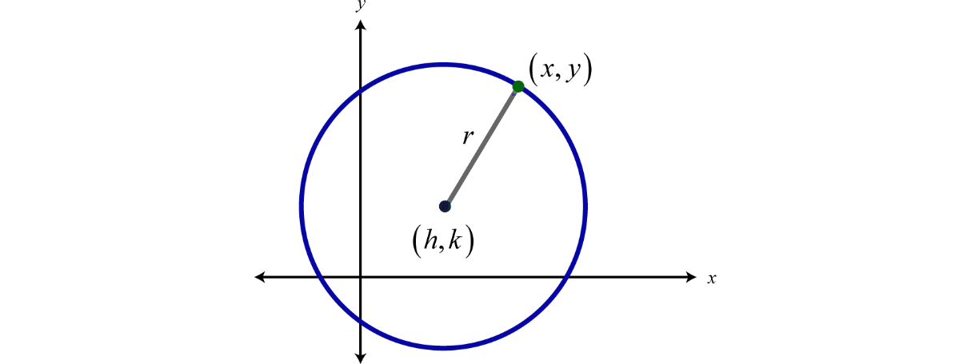Draw a right triangle inside the circle with *r* as the hypotenuse.
8. What are the coordinates for the point where the legs meet?

Label this point N.

1. What is the distance from the ***center*** to point N?

Label this on the figure.

1. What is the distance from point M to point N?

Label this on the figure.

1. What is an expression for the measure of *r*? How did you find it?

**SUMMARY:** The STANDARD FORM for a circle is ________________________________________

**Example 1:** Write the equation of a circle with the given information.

1. Center (0,0), Radius=10

h = k = r =

1. Center (2, 3), Diameter=12

h = k = r =

**Example 2:** Determine the center and radius of a circle the given equation.

1. 
2. 
3. 

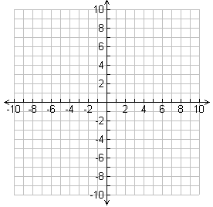**Example 3:** Use the center and the radius to graph each circle.

1. 
2. 

Center:

Radius:

Center:

Radius:

**PART II: General Form**

**Example 4:** Write the equations for the circles shown:

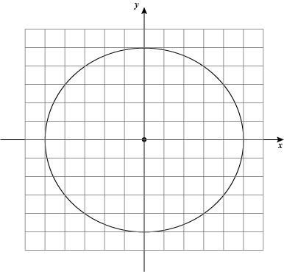a)

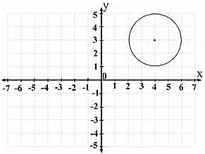b)

**Example 5:** Fully multiply the terms in the equation you found in part b.

**SUMMARY:** The GENERAL FORM of a circle is $Ax^{2}+By^{2}+Cx+Dy+E=0$

Compare the two forms. Which would be easier to use when asked to *graph* a circle?

|  |  |
| --- | --- |
| Writing the Equation of a Circle in Standard Form | |
| ***Step 1:*** | Group x’s and group y’s together. |
| ***Step 2:*** | Move any constants to the right side of the equation. |
| ***Step 3:*** | Use ***“complete the square”*** to make a perfect square trinomial for the x’s and then again for the y’s.  *\*Remember, whatever you do to one side of the equation, you must do to the other!* |
| ***Step 4:*** | Simplify factors into the standard form of a circle! |

**Example 5:** Change the following circles to standard form. Identify the center and the radius of each and then graph.

