HN Math III Day 6 HW – MUST SHOW WORK TO RECEIVE CREDIT Name ___________________________
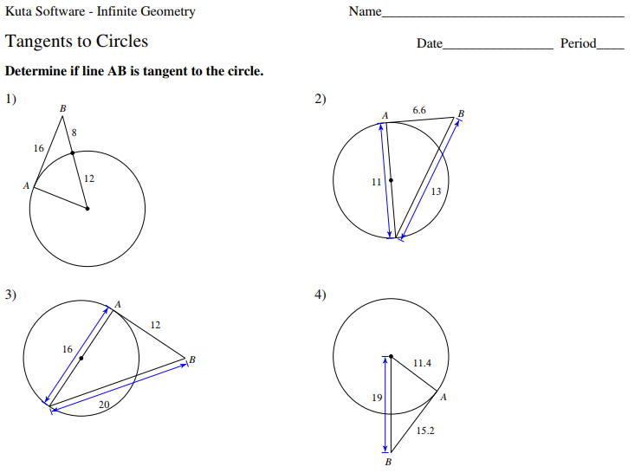
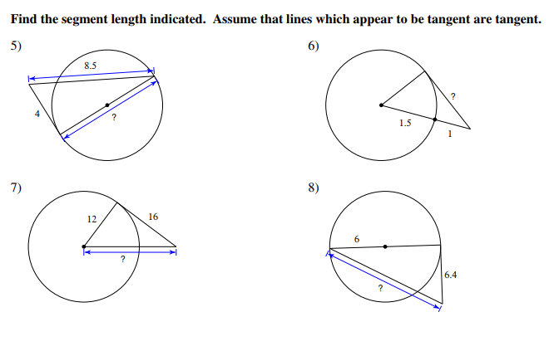

Key:
- Tangent
- Not
- Tangent
- Tangent
- 7.5
- 2
- 20
- 13.6
- 67.4
- 78.8
- 73.4
- 77.8

