Polynomial Functions Review

1. Complete the table below
 | Function | Degree | End Behavior | Domain and Range
A | $$f\left(x\right)=3x^{5}-x^{10}$$ | 5 | (-∞, ∞) | Both all real numbers
B | $$g\left(x\right)=-x^{2}+5x+3$$ | 2 | (-∞, -∞) | D: all real numbers  R: (-∞, 9.5)
C | $$h\left(x\right)=3(x+2)(x-4)$$ | 2 | (∞, ∞) | D: all real numbers  R: (-27, ∞)
D | $$j\left(x\right)=-2x^{3}-x^{2}+5x-1$$ | 3 | (∞, -∞) | Both all real numbers

2. Evaluate the polynomial $f\left(x\right)=3x^{5}-x^{3}+6x^{2}-x+1$ for $x=-2$. Explain what your answer represents.
f(-2) = -61; this means the remainder is -61 if the polynomial was divided by x + 2
3. Find the zeros for the function $f\left(x\right)=x^{3}+3x^{2}-x-3$
The zeros are -3, -1 and 1
4. Show whether -4 is a zero of $g\left(x\right)=x^{3}-x^{2}-14x+24$
g(-4) = 0 which means -4 is a zero of the polynomial
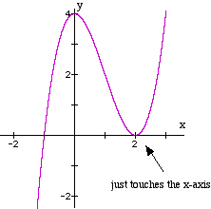
5. Use the graph to answer the following questions
- Relative maximum: (0, 4)
- Relative minimum: (2, 0)
- Increasing interval: (-∞, 0) and (2, ∞)
- Decreasing interval: (0, 2)
- Domain: all real numbers
- Range: all real numbers
- End Behavior: (-∞, ∞)
- Zeros: -1 and 2 (twice)

Find all the zeros
6. $f\left(x\right)=2x^{3}+3x^{2}-39x-20$ and 4 is a zero the zeros are 4, -5 and -1/2
7. $f\left(x\right)=x^{4}+3x^{2}-4$ and 1 is a zero the zeros are 1, -1, 2i and -2i

Divide using long division
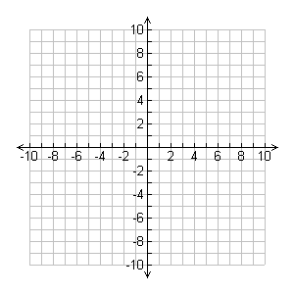
8. $x^{3}-3x^{2}+8x-5÷\left(x-1\right)$ $x^{2}-2x+6+\frac{1}{x-1}$
9. $4x^{3}-12x^{2}-x+15÷\left(2x-3\right)$
$$2x^{2}-3x-5$$
10. Sketch a graph $f\left(x\right)=-4{\left(x-1\right)}^{2}(x-3)(x+8)$
Check graph for zeros at -8, 1 (twice), and 3
The y-intercept is 96; the end behavior is (-∞, -∞)

11. Write the function of $x^{4}$ shifted 3 units down, 4 units left, a reflection over the x-axis and a horizontal compression by 3.
${-\left(3x+4\right)}^{4}-3$
12. A cement walk of uniform width surrounds a rectangular swimming pool that is 10 m wide and 50 m long. Find the width of the walk if its area is 864 m².
$\left(10+2x\right)\left(50+2x\right)-500=864$ x = 6 meters
13. The number of eggs, f(x), in a female moth is a function of her abdominal width, x, in millimeters, modeled by f(x) = 14x³ – 17x² – 16x + 34. What is the abdominal width when there are 211 eggs?
3 millimeters
14. A pyramid can be formed using equal-size balls. For example, 3 balls can be arranged in a triangle, then a fourth ball placed in the middle on top of them. The function p(n) = gives the number of balls in a pyramid, where n is the number of balls on each side of the bottom layer. (For the pyramid described above, n = 2. For the pyramid in the picture, n = 5.)
a. Evaluate p(2), p(3), and p(4). Sketch a picture of the pyramid that goes with each of these values. Check that your function values agree with your pyramid pictures.
p(2) = 4 p(3) = 10 p(4) = 20
b. If you had 1000 balls available and you wanted to make the largest possible pyramid using them, what would be the size of the bottom triangle, and how many balls would you use to make the pyramid? How many balls would be left over?
1000 = 1/6 n(n+1)(n+2)
the largest possible pyramid would be n = 17; there would be 31 balls left over

