Ways to PROVE a quadrilateral is a Parallelogram
Sides | Definition of Parallelogram: If both pairs of opposite sides of a quadrilateral are parallel, then it is a parallelogram. | 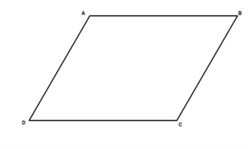
 | If the 2 pairs of opposite sides of a quadrilateral are congruent, then it is a parallelogram.
 | If ONE pair of opposite sides of a quadrilateral is BOTH parallel and congruent, then it is a parallelogram.
Angles | If the 2 pairs of opposite angles in a quadrilateral are congruent, then it is a parallelogram.
Diagonals | If the diagonals of a quadrilateral bisect each other, then it is a parallelogram.

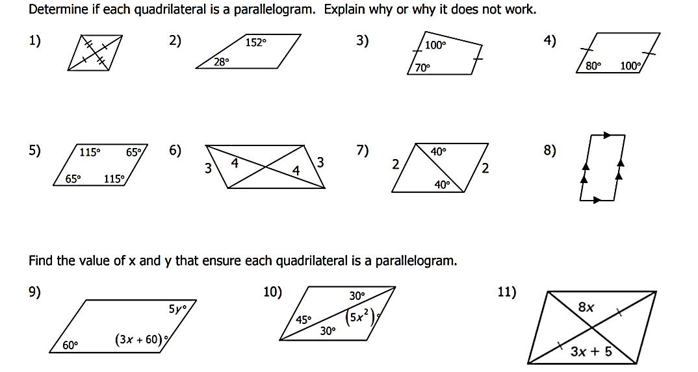
Complete the following proofs:
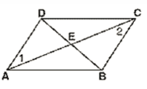
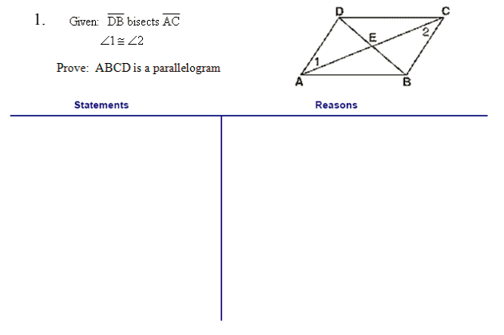
2. Given: DC // AB and ∠1 ≅ ∠2
Prove: ABCD is a parallelogram

DAY 3 HOMEWORK

Find the value for x that will ensure that the given quadrilateral will be a parallelogram:
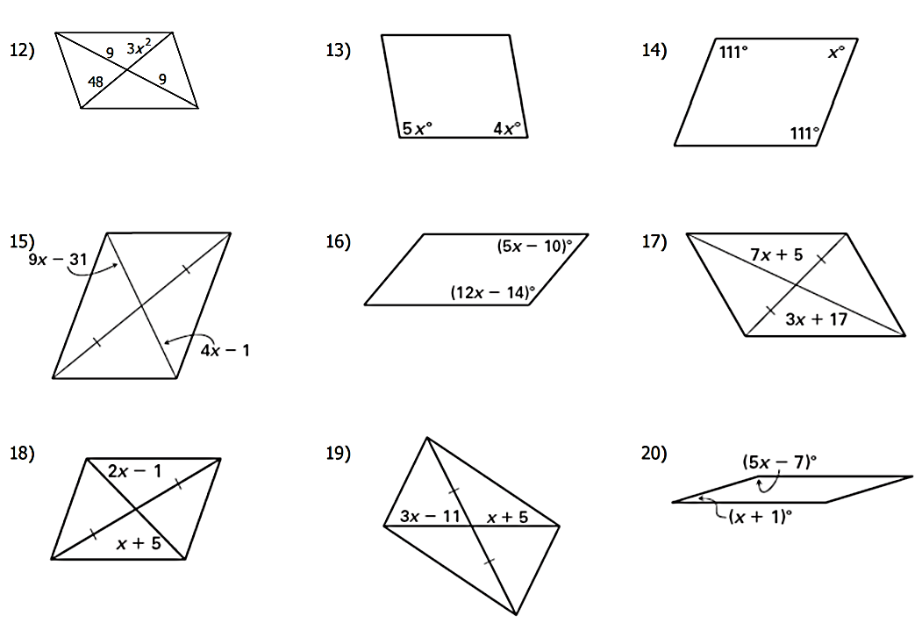
Complete the following proof:
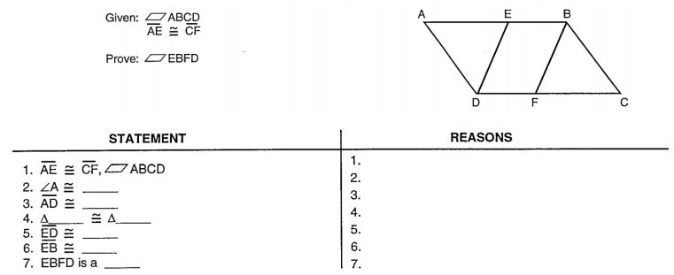
$\overline{ED}$ // $\overline{BF}$

