**Math 3 Review for Final Exam #1 – Centers of Triangles, Polygons, Quadrilaterals, Name __________________________**

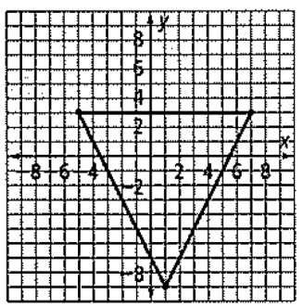

**Solve for x**.

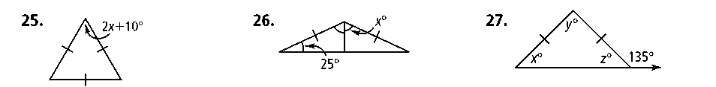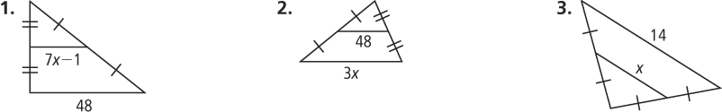1. 2.

**Is a median, an altitude, or a perpendicular bisector?**

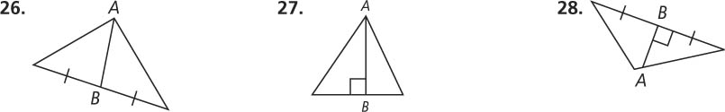3. 4.

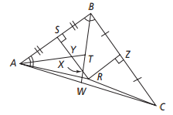

\

#5 – 9

5. Which segment is an angle bisector of ABC?

A. B. C. D.

6. Which segment is a perpendicular bisector of ABC?

A. B. C. D.

7. Which point is the circumcenter of ABC?

A. *X* B. *T* C. *R* D. *Y*

8. Which point is the incenter of ABC?

A. *X* B. *T* C. *R* D. *Y*

9. If RC = x + 3 and RA = 3x - 3, what is the value of x?

A. 3 B. 6 C. 7 D. 9

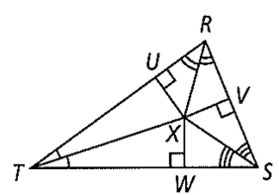

9. *XW* = 3*a* + 5 and *XV* = –2*a* + 15.

Find *XU*.

**circumcenter**

* falls inside when the triangle is acute; outside when it is obtuse, and on the hypotenuse when it is right.
* equidistant from the vertices of the triangle
* is the center of the circle that circumscribes the triangle; the circle that passes through all three vertices



**incenter**

* always falls within the triangle
* equidistant from the sides of the triangle
* is the center of the circle that is inscribed by the triangle; largest circle that will fit inside a circle and touch all three sides



**centroid**

* always falls within the triangle
* is located two-thirds of the way along each median or partitions the median into a ratio of 2:1 with the longest segment nearest the vertex
* divides the triangle into six triangles of equal area
* is the center of gravity for the triangle.

10. Find the coordinates of the

circumcenter of the triangle.

A. (1, -4)

B. (1, -1.5)

C. (2, 0)

D. (-1, -2)

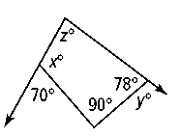12. Find the missing angle measures.

**Find the values of the variables in the parallelogram.**

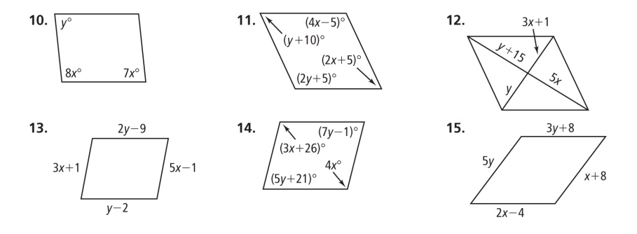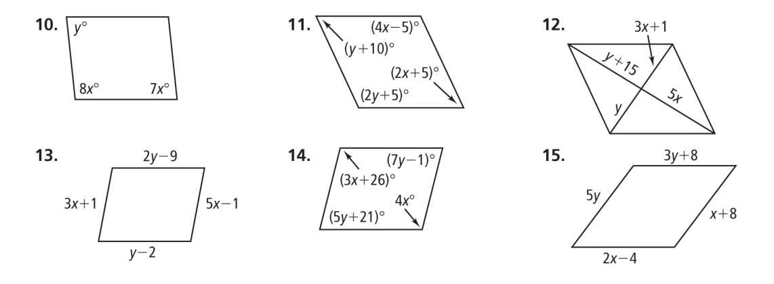13. 14.

**Based on the markings, decide whether each figure must be a parallelogram.**

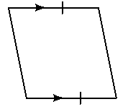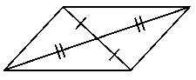15. 16.

**For each parallelogram, determine the most precise name and find the measures of the numbered angles.**

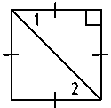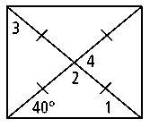17. 18.

**Find *x* for the rhombus and trapezoid.**



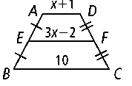19. 20.

**Math 3 Review for Final Exam #3 –Circles: Geometric Properties & Equation Name __________________________**

**Assume that the lines that appear to be tangent are tangent. *P* is the center of each circle.** Find the value of *x*.

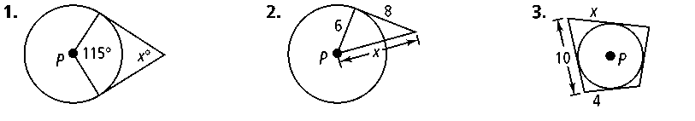1. 2.

.

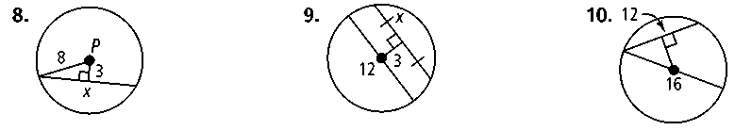**Find the value of each variable.**



*x*

3. 4.

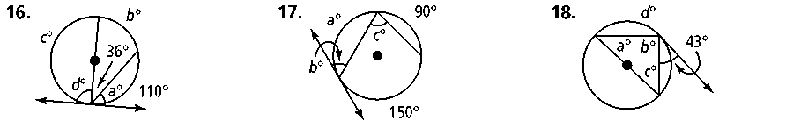

108

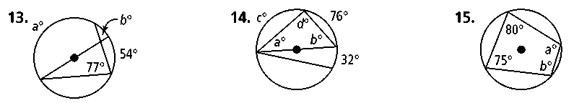5. 6.

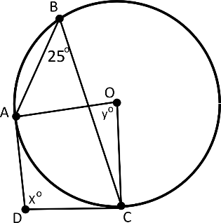

25.

**Find the center and radius of each circle.**

12. (*x* + 1)2 + (*y* + 3)2 = 1

13. 

**Find each measure for the circle: (a) Area of smaller sector (b) length of the shorter arc. Leave answers in terms of *π.***

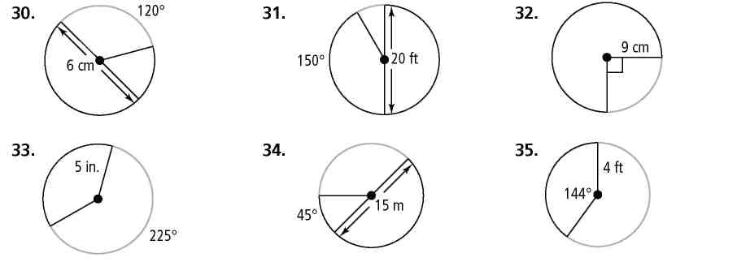16. 17.



18. Determine whether

a tangent line is shown.

19. How many points with two integer coordinates are 5 units away from (-2, 3)?

20. The length of an arc is 18 cm and the radius of the circle is 6cm. What is the radian measure of the central angle?

21. Write the equation of a circle that is centered at (-1,3) with a radius of 5 units.

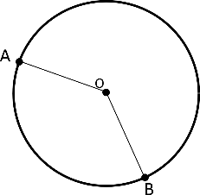29. Given that  and the radius is 18 cm, what is the length of arcAB ?

**Math 3 Review for Final Exam #4 – Special Rt Triangles & Right Triangle Trigonometry Name ______________**

**In ∆*RST*, ∠*S* is a right angle and $\cos{R= \frac{12}{13}}$. Draw a diagram and find each trigonometric ratio.**

1. sin *R* 2. sin *T* 3. cos *T* 4. cos *R*

**Find the value of *x*. Round lengths of segments and angle measures to the nearest tenth.**

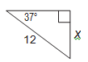

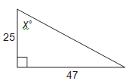

5. 6.

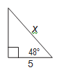

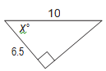

7. 8.

**Write each measure in radians.**

9. 270° 10. −100°

**Write each measure in degrees.**

11. 5*π* 12.−

**(A) Sketch each angle in standard position.**

**(B) State the quadrant of the terminal side.**

13. 400° 14. −195° 15. $\frac{3π}{4}$ 16. $- \frac{2π}{3}$

**State the period, amplitude, shifts.**

17.  18.

**Find the exact value of each expression using a unit circle OR sketching the right triangle/reference angle.**

19.  20. 

21. cos 180° 22. 

25. A periodic function has a period of 12 s. How many cycles does it go through in 40 s?

26. An angle in standard position intersects the unit circle at (0, -1). What could be the angle measure?

31. A stink bug has crawled into a box fan and sits on the tip of the 1-foot long blade of the fan as seen below. The fan starts to turn slowly due to a breeze in the room.

1. Create a function and a graph that describes its change in height from its original position based on the angle of the blade from its original position.
2. 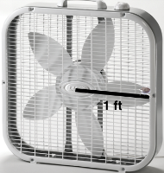What is the height of the stink bug when the blade has rotated 2 radians?

$\frac{11π}{6}$ radians?

1. How much has the blade rotated when the stink bugs height is $-\frac{3}{4}$ feet? Can there be more than one answer?

**Math 3 Review for Final Exam #5 – Function Notation & Graphing, Inverses, Systems Name __________________________**

1. Given , find

A. *f*(-2) C. *f*-1(*x*).

**Find the inverse of each function. Is the inverse a function?** 2.  3. $f\left(x\right)= \frac{1}{3}x+3$ 4. $y=4{(x-1)}^{2}$

**Describe the transformation of parent function *f* (*x*).**

7. *g*(*x*) = *f*(*x*) + 2 8. *h*(*x*) = *f*(*x* − 1) 9. *h*(*x*) = −3*f*(*x*)

11. Which are inverses?

30. Graph the inverse of $f\left(x\right)= -\frac{3}{2}x-3$. How does $f^{-1}(x)$ relate to $f(x)$?

|  |  |  |  |  |  |
| --- | --- | --- | --- | --- | --- |
| x | 1 | 2 | 3 | 4 | 5 |
| f(x) | 2 | 4 | 9 | 4 | 12 |

32. Consider the table. Write the inverse of the relation. Is it a function?

**Math 3 Review for Final Exam #6- Polynomial Expressions, Functions, & Graphs Name __________________________**

1. Write each polynomial in standard form. Then classify it by degree and by number of terms. 3*n*2+ *n*3– *n* – 3 – 3*n*3

3. Factor

4. The expression $(x + 4)$ is a factor of $x^{2}+kx-20$. What is the value of *k*? How do you know?

5. Factor

6. What are the solutions to the polynomial:

?

7. Write two distinct polynomials, in factored form, with solutions at 1, $\frac{4}{3}$, and a double root at .

8. Find the zeros of each function. (a) *y* = (*x* − 3)(*x −* 4)2  (b) *y* = *x*2(*x +* 1)3

9. Find the real or imaginary solutions of each equation by factoring.

(a) *w*4+36= 13*w*2 (b) *x*3+27=0 (c) *t*3−3*t*2−10*t=*0

12. Determine the transformation of the cubic parent function *y =* *x*3.

(a) *y=* 2*x*3 (b) *y=* (*x*+5)3 (c) *y=* -*x*3+4

15. Divide (distribute, long or synthetic).

(a)

(b) (*x*3 + 11*x +* 12) ÷ (*x* – 2)

(c)

16. Find the relative maximum and minimum of the graph of *f*(*x*) = *x*3 − 3*x*2 + 2.

18. Build polynomial functions with a double root at $-2$ and another root at $5$.

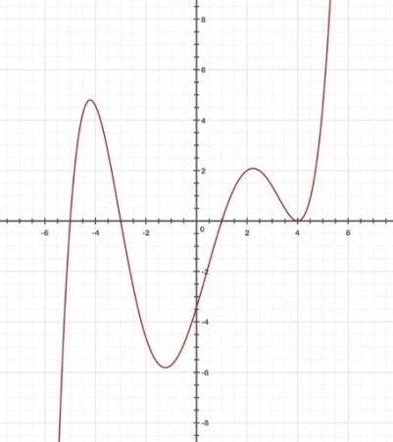21. For the function, label and

describe the key features:

intercepts, relative max/min,

intervals of increase/decrease.

**Math 3 Review for Final Exam #7- Exponent, Logarithmic, & Rational Functions Name __________________________**

**Determine whether each equation represents exponential growth or exponential decay. State the initial amount and percent of growth/decay.**

5. *y* = 0.5(1.67)*x* 6. *y* = 1.023(0.98)*x* 7. *y* = 35*e-4x* 8. *y* = 400*e3.2x*

**Write each equation in logarithmic form. Write each equation in exponential form.**

9. 93 = 729 10.  11. log *n* = 3 12. *ln* 1 = 0

**Evaluate each logarithm without a calculator.**

13. log 1000 14.  15. 5 ln 1 16.  17. log27 9 18. 

**Solve each equation.**

21.  22. 2 − 4*x* = −62 23. log3 (*x* + 1) = 4 24. *e*3*x* = 20

25.  26. log *x* = −2 27.  28. ln (*x* + 2) = ln(4*x*)

**Simplify. State any restrictions on the variables (what values make the denominator = 0?).**

32.  33.  34.  35.  36. 37. 

38. 40. 41. 42. 

**Solve each equation. Check each solution.** 44. 45. 

**Math 3 Review for Final Exam #8- Statistics, Modeling, Applying & Analyzing Functions Name _______________________**

1. Find the mean for the data set. 12 9 10 11 13 9 20

2. Determine what type of study would establish a cause-effect relationship for each situation: an observation, a simulation, an experiment, a survey. (a) cell-phone use and brain tumors (b) fertilizer use and plant growth

4. From a class containing 10 girls and 18 boys, four students are to be selected to serve on a school advisory panel. Here are four different methods of making the selection.

1. Select the ﬁrst 4 names on the class roll.
2. Select the ﬁrst 4 students who volunteer.
3. Place the names of the 28 students in a hat, mix them thoroughly, and select three names from the mix.
4. Select the last 4 students who show up for class tomorrow.

Which is the best sampling method, among these four, if you want the school panel to represent a fair and representative view of the opinions of your class? Explain why?

6. A student wants to determine the difference if other students can identify whether a drink is Coke or Pepsi. Which type of study would be the most practical to obtain this information? Explain why.

A. simulation B. experiment C. survey D. observation

**Math 3 Review for Final Exam #9-10: Function Applications and Modeling Name _______________________**

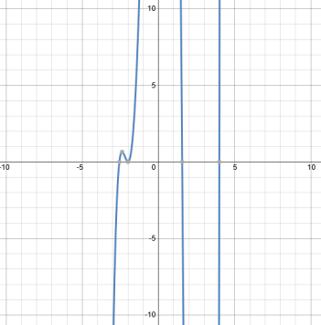

6. What is the lowest possible degree of the function graphed below? How do you know?

What is another possible degree for the function?

7. Build a polynomial function that could represent the following graph,

and explain how each characteristic you could see on the graph helped

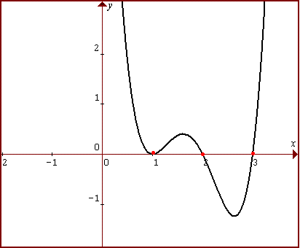you build the function.

9. A manufacturer bought a new rolling press for $48,000. It has depreciated in value at an annual rate of 15%. What is its value 5 years after purchase? Round to the nearest hundred dollars.

10. You place $900 in an investment account that earns 6% interest compounded continuously. Find the balance after 5 years.

14. Graph and answer the following questions:

1. What is the period?
2. What is the amplitude?
3. What is the vertical shift?

21. If the world population at the beginning of 2008 was 6.7 billion and growing at a rate of 1.16% each year, in what year will the population be double?

23. For the following function: $h\left(x\right)=\left\{\begin{aligned}2^{x}, &x<-3 \\ \frac{3}{x}, &x≥-3\end{aligned}\right.$

1. Evaluate $h(-4)$.
2. Evaluate $3 h(0) + 2 h(-3) – h(-6).$
3. What is the domain of $h(x)$? Explain your answer.